**Assignment:1**

**Q1 Convert following numbers into decimal**

(11011.101)2 (475.63)8 (FB7.C9)16 (763.82)9 (46.532)7

**Q2 Perform the following conversions**

(479.83)10=(?)8 (475.63)10=(?)16  (475.63)10=(?)16 (475.63)10=(?)7

**Q3 Perform the following conversions**

(478)9=(?)8 (465)7=(?)6  (4756)8=(?)7 (11011)2=(?)4

**Q4 Without converting into decimal, perform the following conversions**

(11111001101.1011)2=(?)8 (EFC9.A7)16=(?)8  (475.762)8=(?)16 (11011)2=(?)4

**Q5 Determine r’s compliment and (r-1)’s compliment of the following numbers**

(11011.101)2 (475.63)8 (FB7.C9)16 (763.82)9 (46.532)7

**Q6 Perform the following mathematical operations**

(476.23)8 + (763.25)8 =(?)8 (476.23)8 + (AF2.5C)16 =(?)8 (1111001101.101101)2 + (763.25)8 =(?)16

(476.23)9 + (783.54)9 =(?)9 (546)7 + (863)9=(?) (362.74)8 x (76)8 =(?)8  (EF9)16 x (9F)16 =(?)16

**Q7 Perform the following mathematical operation**

(FBD.23)16 - (A32.5C)16 =(?)16 (1111001.101)2 - (100100.111)2 =(?)2 (756.23)8 - (363.25)8 =(?)8

(476.23)8 + (EFC9.A7)16 - (AF2.5C)16 =(?)8

**Q8 Subtract following numbers by r’s compliment and (r-1)’s compliment method.**

(FBD9.E3)16 - (A52C.3A)16 (56.43)8 - (763.25)8 (476.23)9 - (783.54)9 (111101.101)2 - (10100.11)2

**Q9 Subtract following numbers by 1’s compliment and 2’s compliment method.**

(FBD9.E3)16 - (A52C.3A)16 (56.43)8 - (763.25)8 (111101.101)2 - (10100.11)2

**Q10** If (211)x = (152)8, find the value of base x

**Q11** If (135)x+(144)x= (323)x ,find the value of base x

**Q12** Find the value for x which 32 in base four = 22 in base x?

**Q13** What is the base (or radix) of the number if the solution to the quadratic equation

X2-10X+31=0 is X=5 and X=8.

**Q14: Simplify the following using Boolean rules**

 (A + B)'(C + D + E)' + (A + B)'  AB + ABC + ABCD + ABCDE + ABCDEF

(A+B+C) (D+E)' + (A+B+C) (D+E) 

 

 

 

**X′Y + YZ′ + YZ + XY′Z′ (A + B’ + C’)(A + B’ + C)(A + B + C’)**

 

**Q15: Express the following in canonical SOP and Canonical POS form**

F (A, B, C) = (A’+C) (A+C’) (B+C) F (A, B, C) = (A’.C) + (A.C) + (B’.C)

F (A, B, C, D) = (A’+C+D) (A+B+C’) (B’+C’+D) (A+B+D’)

F (A, B, C, D) = (A’CD)+ (ABC’) + (B’C’D) +(ABD’)

**Q16: Derive Boolean expression in minimal(simplified/standard) form for the following digital circuits and sketch truth table**

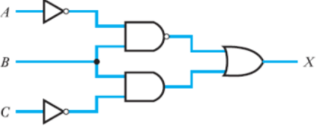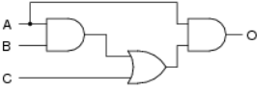

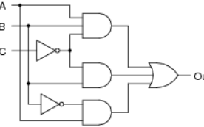 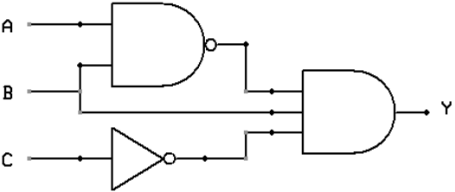

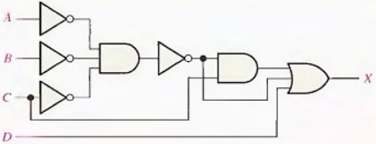 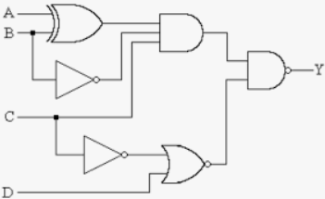

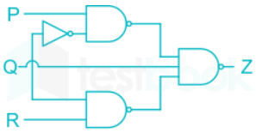 

**Q17: Minimize the following by K map and realize the minimized function by (i) Basic gates (ii)NAND gate only (iii) NOR gate only**

F (A, B, C, D) = Σm (0, 1, 2, 5, 7, 8, 9, 10, 13, 15) F (A, B, C,) = Σm (0, 1, 2, 3, 6)

F (A, B, C, D) = πM (0, 1, 3, 5, 7, 8, 9, 11, 13, 15) F (A, B, C,) = πM (0, 1, 3, 5)

**Q18: Minimize the following by K map**

F (A, B, C, D) = Σm (1, 3, 4, 6, 8, 9, 11, 13, 15) + Σd (0, 2, 14)

F (A, B, C) = Σm (1, 2, 5, 7) + d (0, 4, 6) F (A, B, C) = πM (0, 1, 6, 7) + d (3, 4, 5)

F (A, B, C, D) = πM (0, 2, 8, 10, 14) + d (5, 15)

**Q19: Represent F1, F2 in canonical SOP & POS forms then simplified (standard) SOP & POS forms**.

